# CS 255 System Design Document Template

This template lays out all the different sections that you need to complete for Project Two. Each section has guidance to prompt your thinking. You will need to continually reference the interview transcript as you work to make sure that you are addressing your client’s needs. There is no required length for the final document. Instead the goal is to complete each section based on what your client’s needs are. Remove this note when you are finished, and replace all bracketed text with the relevant information.

## UML Diagrams

### UML Use Case Diagram

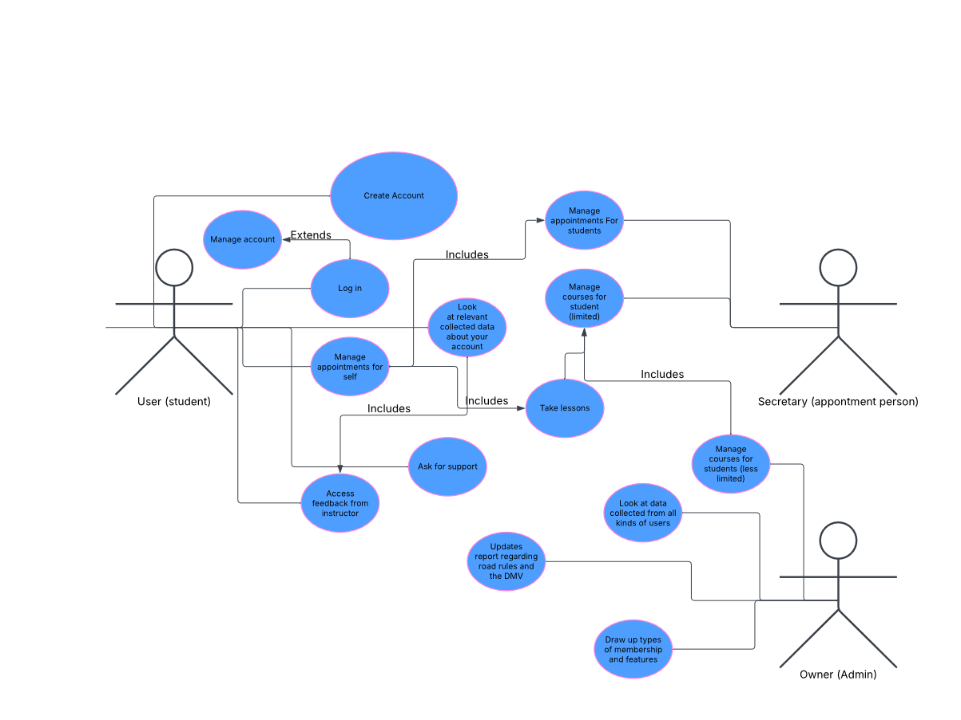

### UML Activity Diagrams

### UML Sequence Diagram

### UML Class Diagram

## Technical Requirements

*For hardware we should utilize server hosting, so that we may allow our users to connect to the DriverPass program. We also need a place and necessary hardware to store user data such as account information, course information, user progress, different packages we want to sell to clients, etc. The last large thing we need is a network that allows the user to go from the application to the database for all their information and the servers that are hosting the program and back to their device of choice.*

*We want the program to be usable on a multitude of devices such as mobile and desktop environments. We need support for operating systems such as windows and Linux as well as mobile platforms like Android and Apple, so all the hardware must not have compatibility problems, or make accommodations for all the device types we plan on supporting.*

*The DriverPass program also needs a webhost to be able to be super relevant. It’s important that we can give the platform to people that would like to exclusively use the service within their web browser, so offering a website is valuable and we will investigate buying a web service.*

*To design DriverPass, we need an environment to code in. We will utilize a program such as javascript or perhaps CSS to create the program.*

*We can also use programs like visual studio or eclipse to develop our code. This gives us access to debugging tools and platforms with a lot of support to put us in a good position to start development and streamline the process.*

*Infrastructure that will be crucial to development and upkeep will be the engineers that will continue to support the platform as necessary along with cooperation from the team that is responsible for running the operation so that we can provide necessary accommodation from the team that is going to be using the system. The team and all the machines along with them serve as crucial pieces of infrastructure that maintains the success of the platform.*